Laplace Transform

Definition: The tools that makes it possible to represent arbitrary input f(t) in terms of exponential component.

Forward Laplace Transform

f(t) ----------L---------> F(s) where s = $σ$ + jw (complex)

Inverse Laplace Transform

f(t) <-------L-1-------- F(s)

Bilateral Laplace Transform Pair

Example: Find Laplace Transform of:

a) $δ$ (t) 🡪 delta, impulse function

b) u(t) 🡪 unit step function

c) cos(w0 . t) . u(t) 🡪 cosine function

Solution:

(a)

Delta function has only non-zero value at t=0, rest is 0

(b)



(c)



Shortcut: Table 4.1 in your textbook, Laplace Transform pairs. You have this in exam, don’t memorize.

Inverse Laplace Transform

Example: Partial Fraction Expansion (PFE) method

*Side notes:*

Example:

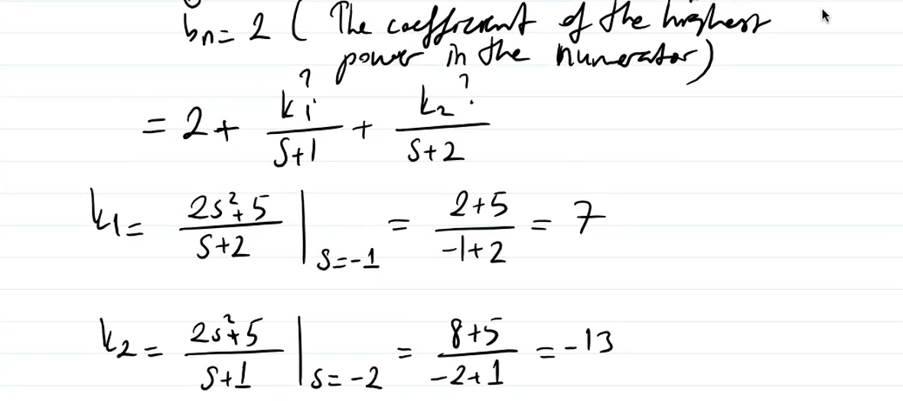

Inverse of 1 is $δ$ (t).

Some Properties of Laplace Transform

*Time-Shifting:*

if f(t) ⬄ F(s), then for t0 >= 0,

f(t – t0) ⬄ F(s) . e-s . t0

Example:

*Frequency-Shifting:*

If f(t) ⬄ F(s), then

f(t) . es0 . t ⬄ F(s – s0)

Example:

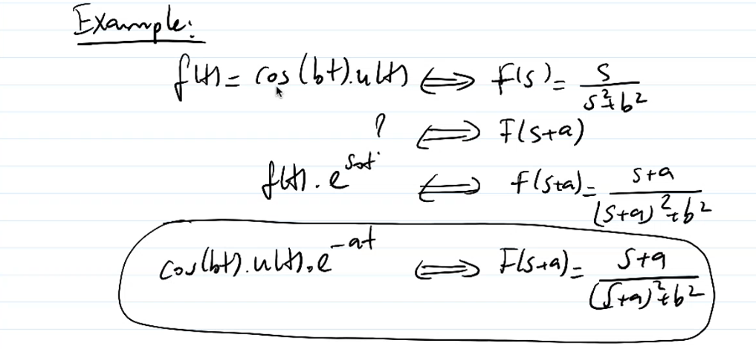

*Time-Differentiation:*

If f(t) ⬄ F(s), then

*Time-Integration:*

*Scaling:*

*Time-Convolution and Frequency-Convolution:*

Example:

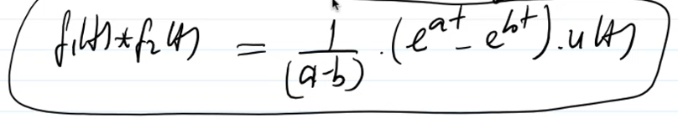

Zero-State Response: The transfer function of LTIC system

Consider nth order LTIC system with:

Q(D) . y(t) = P(D) . f(t)

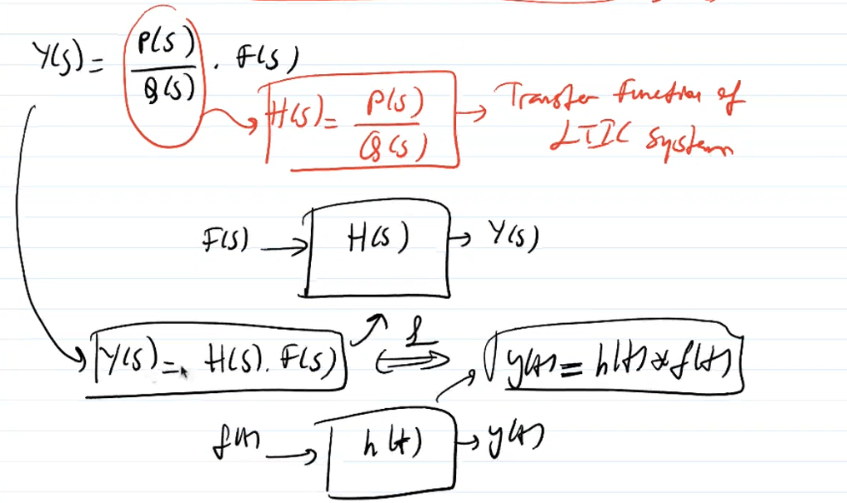

Example:

Find the response y(t) of the following LTIC system,

Solution:

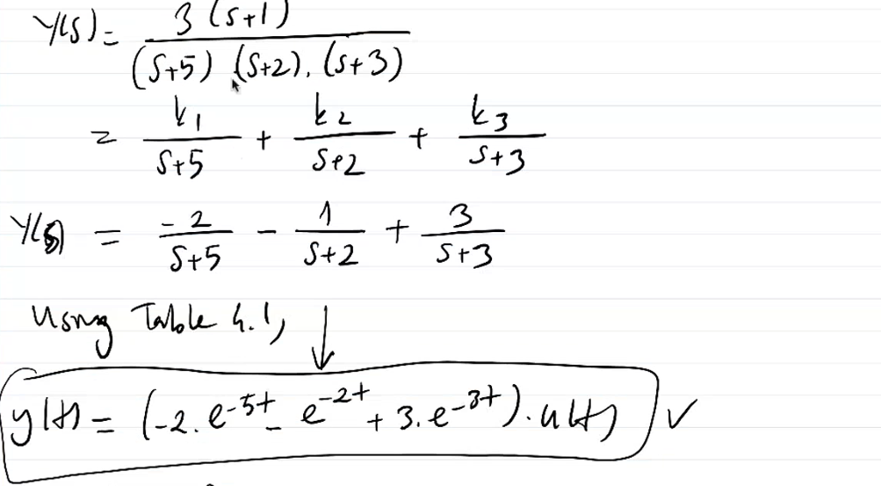

Block Diagrams

Large systems may consist of a very large number of components (subsystems)

Analyzing such large systems all at once could be very complex

In such case, it is convenient to represent a system by suitably interconnected subsystems, each of which can be analyzed easily

Subsytems may be interconnected using 3 interconnection types:

* cascade
* parallel
* feedback

*Cascade:*

*Parallel:*

*Feedback:*

E(s) --> Error signal